**Topcoder - Create Consolidated Environment For Informix, Direct And Online Review**

**Verification Guide**

Revision History

|  |  |  |
| --- | --- | --- |
| **Author** | **Revision Number** | **Date** |
| TCSCODER | 1.0 | 08/13/2016 |

1. Preparation 3

2. Verification 3

# 

# Preparation

Please start the docker containers as indicated in the readme.md file first.

Open your informix database client, and connect to the tc-informix docker container, and execute the following sql (which will accept all the terms for all users, so that you won’t get error when editing the projects in online_review later):

DATABASE tcs_catalog;

INSERT INTO user_terms_of_use_xref

SELECT u.user_id, t.terms_of_use_id, CURRENT, CURRENT

FROM user u

JOIN terms_of_use t ON 1=1

LEFT JOIN (SELECT user_id, terms_of_use_id FROM user_terms_of_use_xref) x

ON x.user_id = u.user_id AND x.terms_of_use_id = t.terms_of_use_id

WHERE x.user_id IS NULL;

Note that the tc-informix database is running on <docker-box-ip> at 2021 port with informixoltp_tcp as the server name. And the database username/password is: informix/1nf0rm1x

The <docker-box-ip> is the ip address of your docker box. And here is my configuration in [DbVisualizer](https://www.dbvis.com/) tool:

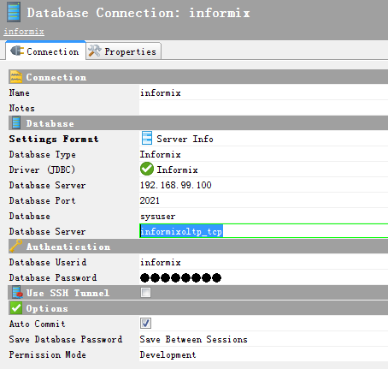

# Verification

Log into the direct with heffan/password:

<https://cockpit.cloud.topcoder.com/direct>

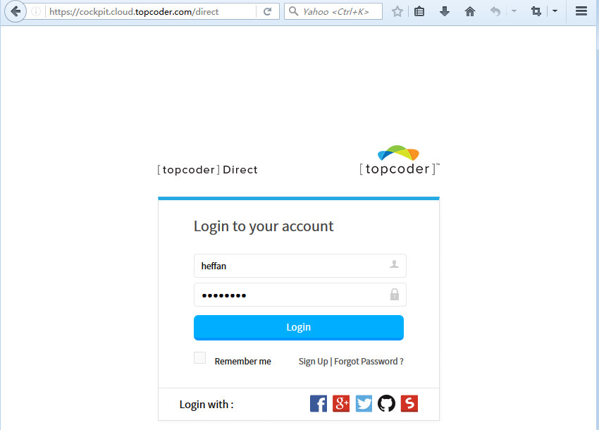

Then open <https://cockpit.cloud.topcoder.com/direct/launch/home> to create a new challenge.

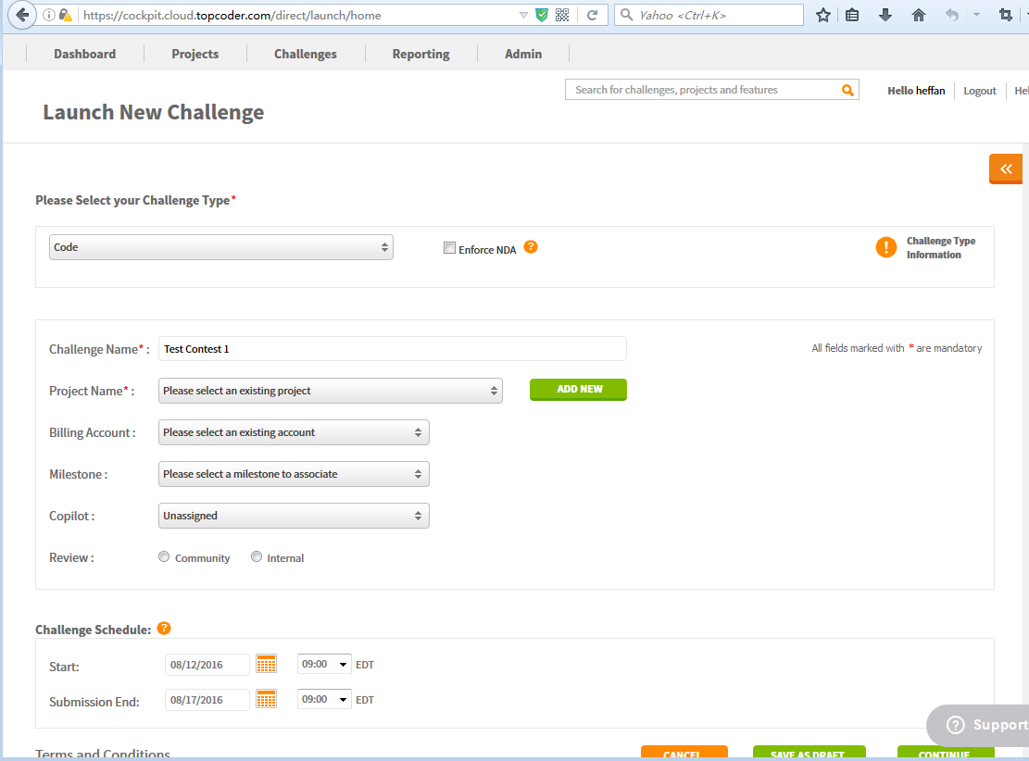

Please click the green “ADD NEW” button above to create a new project first. Fill in anything you like, and click the “CREATE” button to create the project.

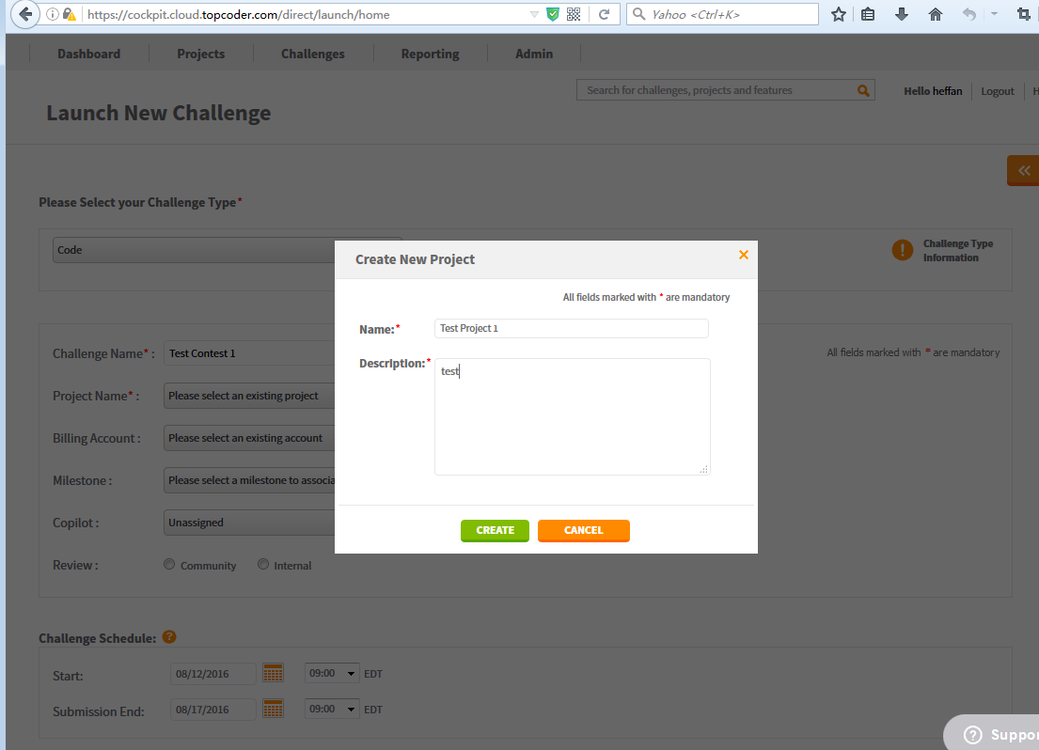

Then click the “Add Billing to project” link (highlighted below) to add a billing account to the project:

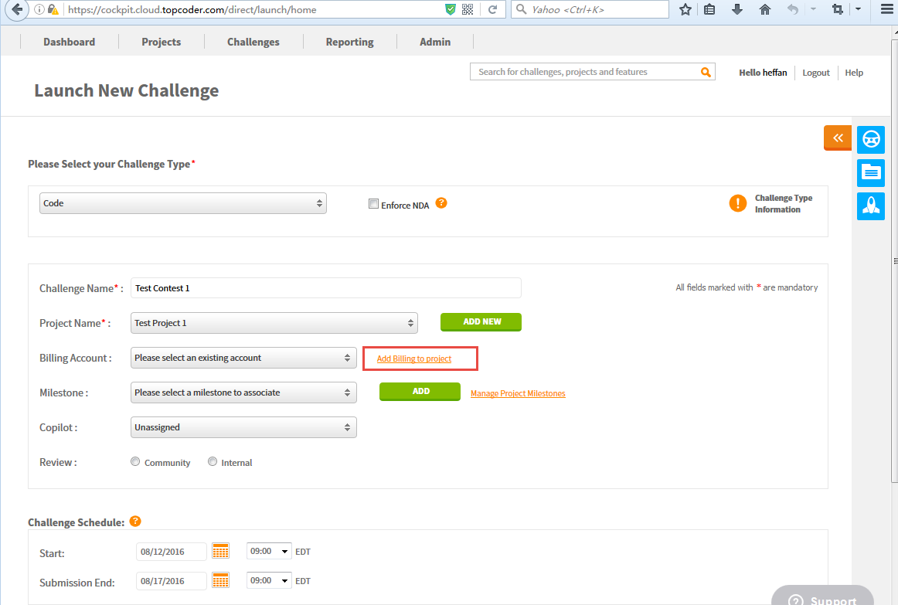

Select a Billing Account from the dropdown list, and then click “ASSOCIATE BILLING” button.

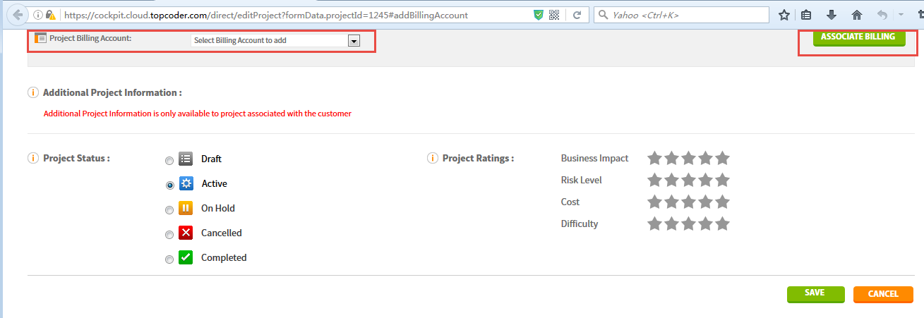

Reopen the <https://cockpit.cloud.topcoder.com/direct/launch/home> page, select “Code” challenge type; enter the challenge name; and select the project name, billing account created in steps above.

Then select the “Community Review” option, and then click “SAVE AS DRAFT” button, then confirm in the popup to save it as draft, and finally click the view challenge button in popup to open the contest details page.

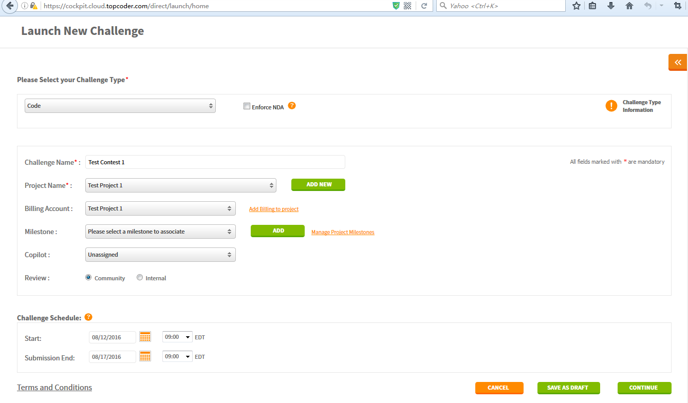

Here is the contest details page:

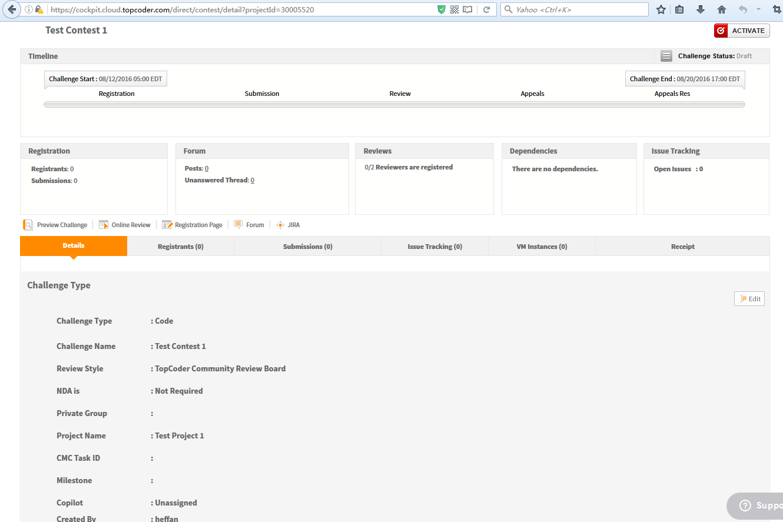

Scroll down the page to the “Specification” section, and click the “Edit” button to fill the missing details.

You can input anything you like, and then save the changes.

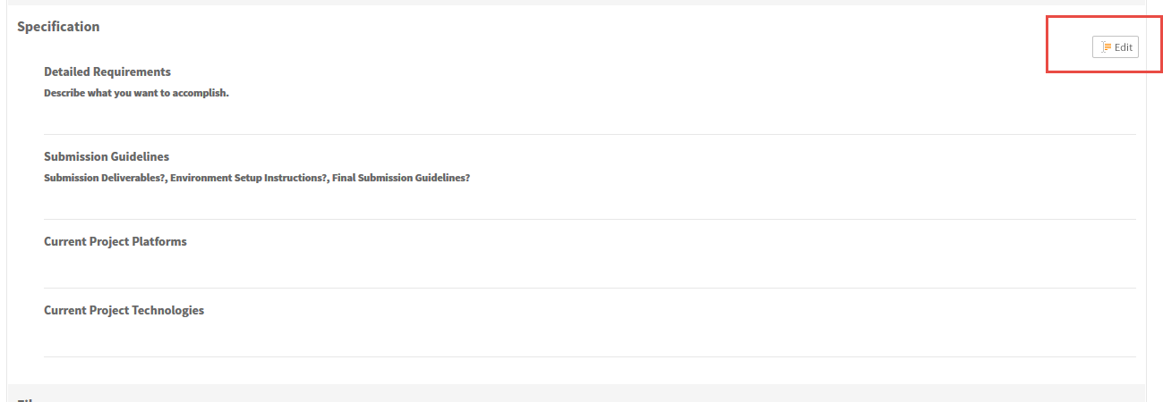

Finally scroll down to the bottom, and click the “Activate” button to activate the contest:



After the contest is activated, click the “Online Review” link to go the contest page in Online Review:

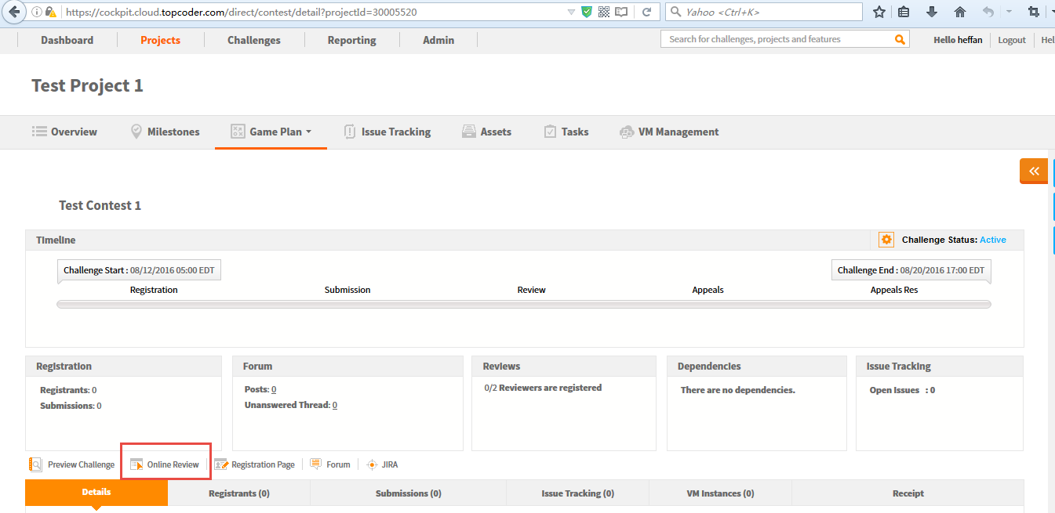

You should be logged into the Online Review automatically, with the following page displayed:

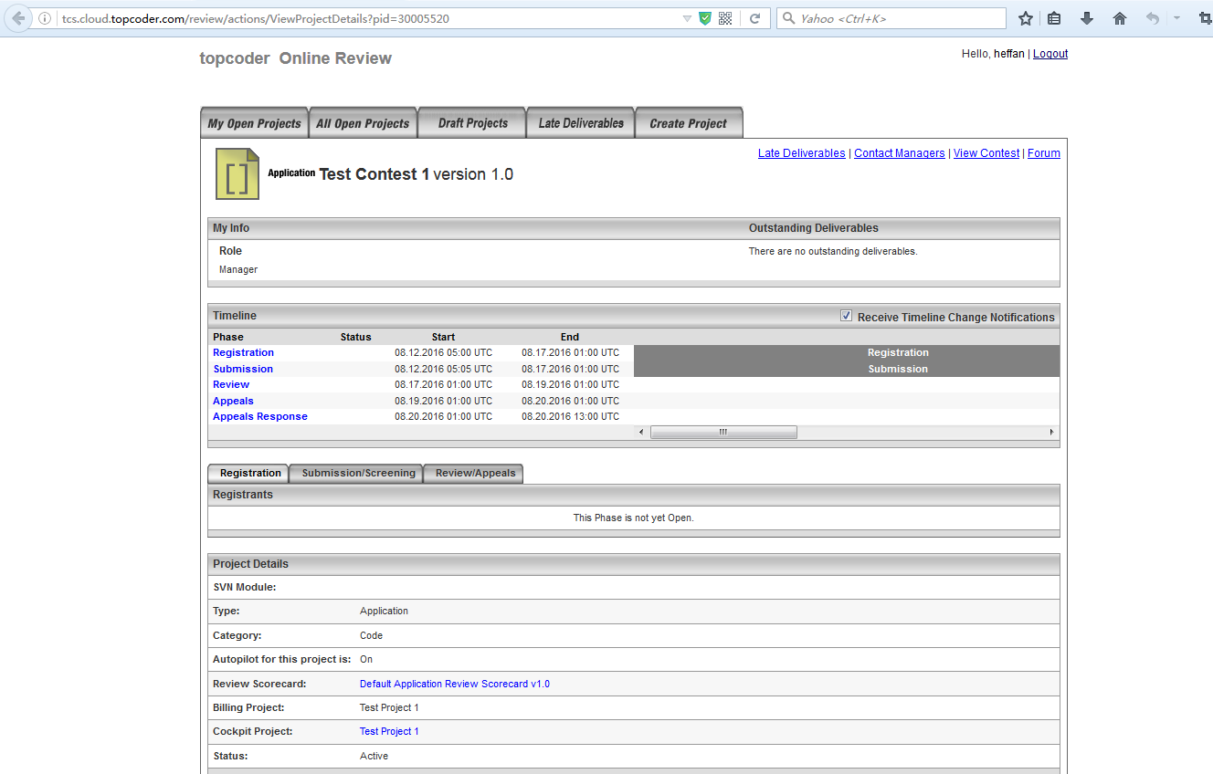

Scroll down the page above and click the “Edit Project” button to open the edit page.

Then do the edits on this page:

* + - Edit the Registration phase start time to open the registration phase.
    - Edit the Registration and Submission phases’ end time to end them in a shorter duration.
    - Change to require 1 reviewer before ending the Review phase.
    - Edit the Resources to add a submitter and reviewer. You can add *user* as submitter and add *twight* as reviewer.
    - Input a random integer value as the Forum Id

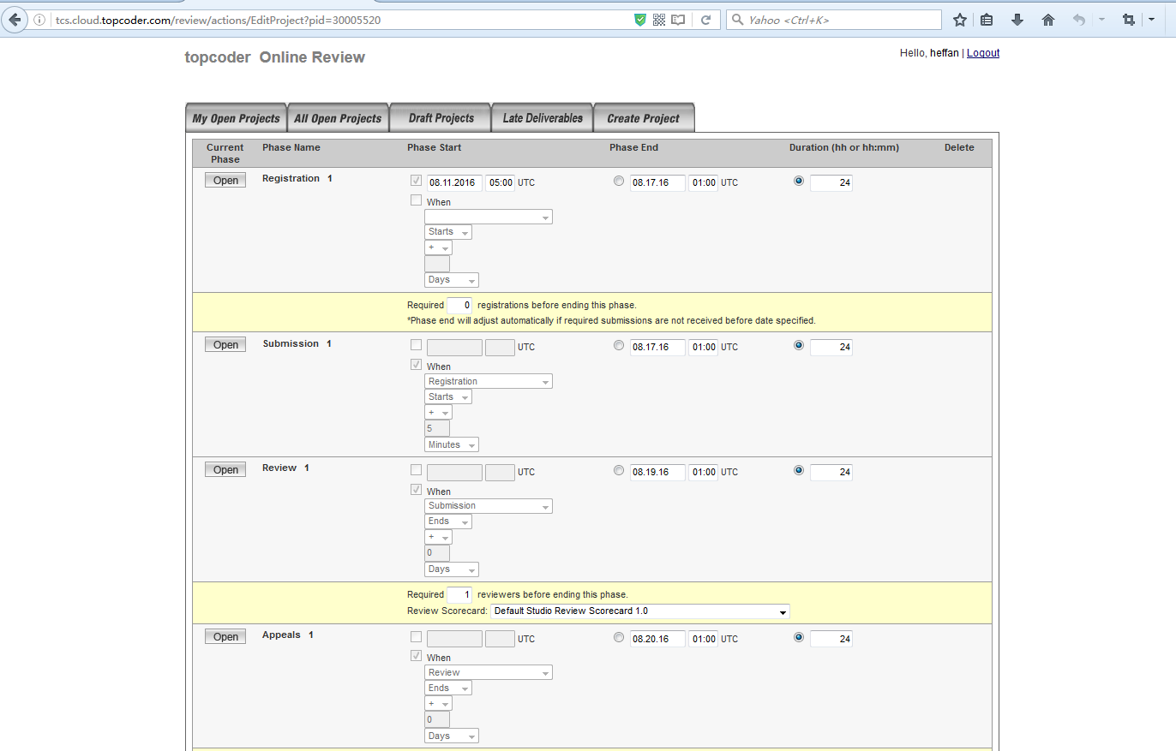

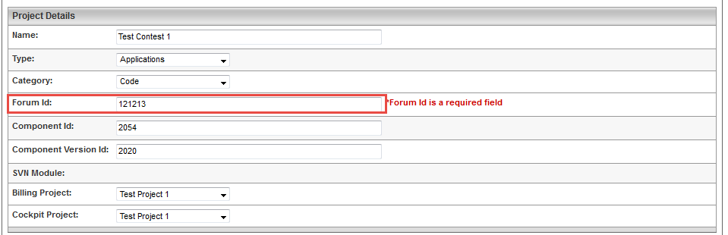

The Resources section should be changed to like this:

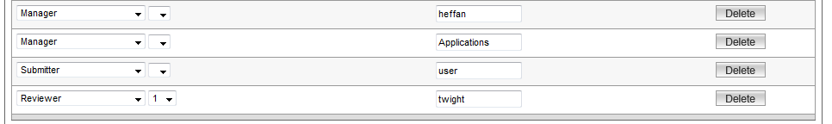

Finally click the “Save Changes” button on this page to save the changes. You will see an error page displayed as below. It doesn’t matter, the changes are saved correctly.

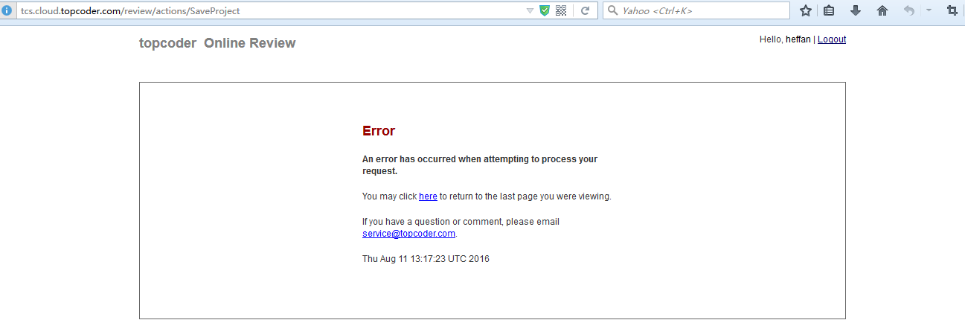

Now reopen the contest page in Online Review, you can see the changes are saved correctly.

Make sure the submission phase is open. Logout and re-login the Online Review with user/password (who is the submitter). It’s better to do this in a different browser, and you can open the <http://tcs.cloud.topcoder.com/review> to access the login page.

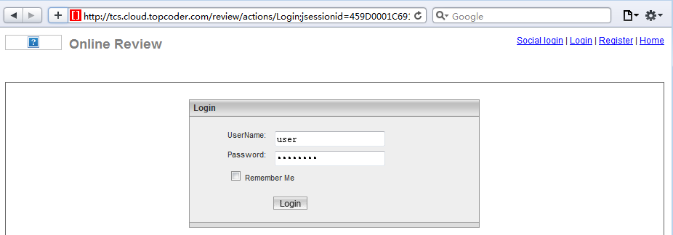

After logged-in, open the test contest you created earlier.

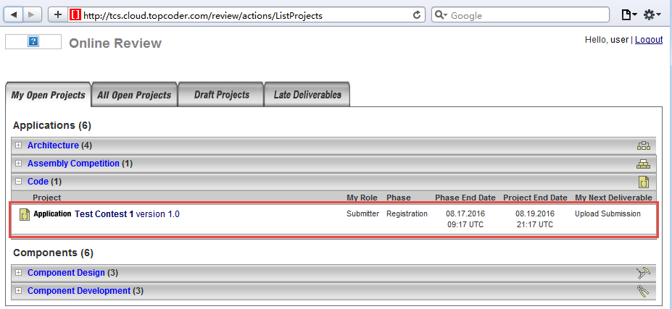

On the contest page, click the “Upload Submission” link, and then upload any file:

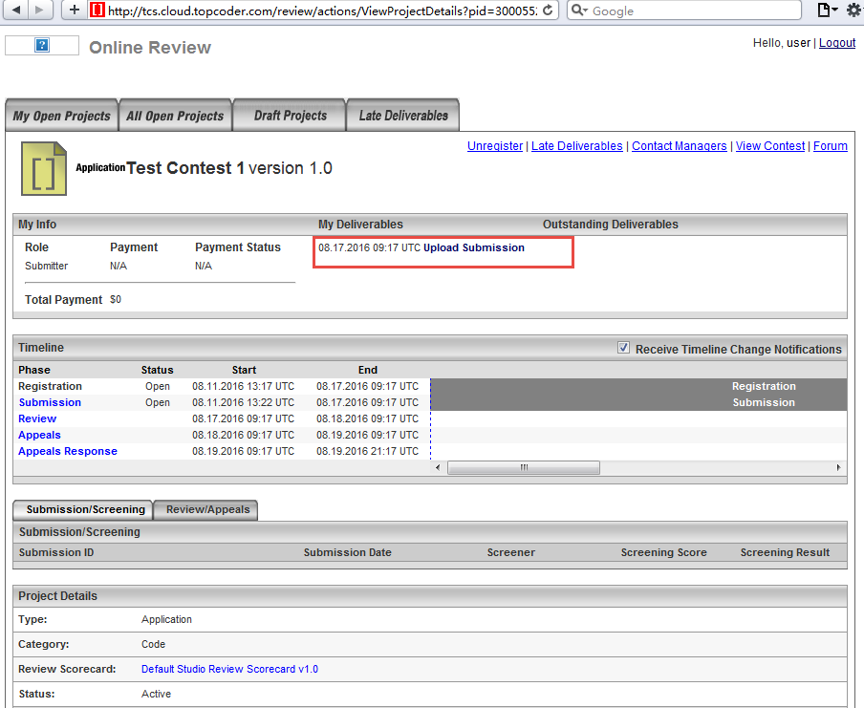

After the submission is uploaded, the page is as below:

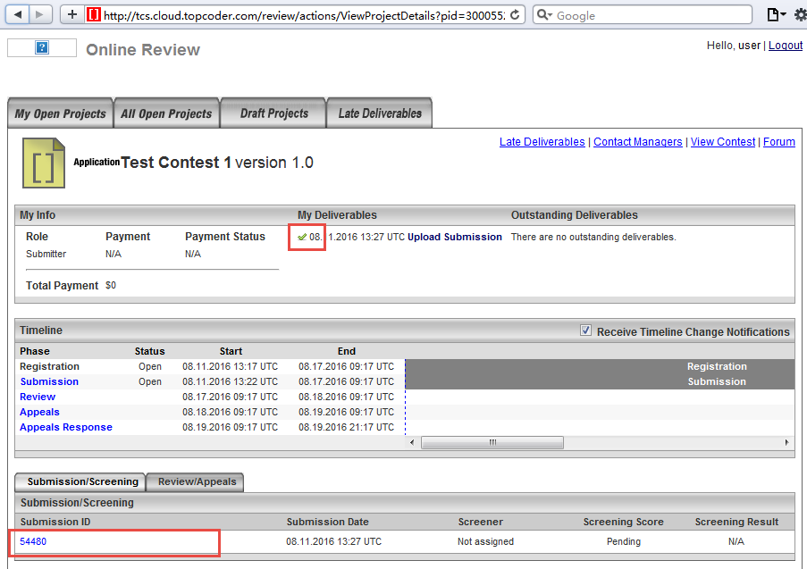

Now we have a submission for this contest, we can wait until the Submission phase is closed (you can make the Registration and Submission Phase even shorter). The auto-pilot will close the Submission phase and open the Review phase automatically when the time comes.

After the Review phase is open, login the Online Review with twight/password:

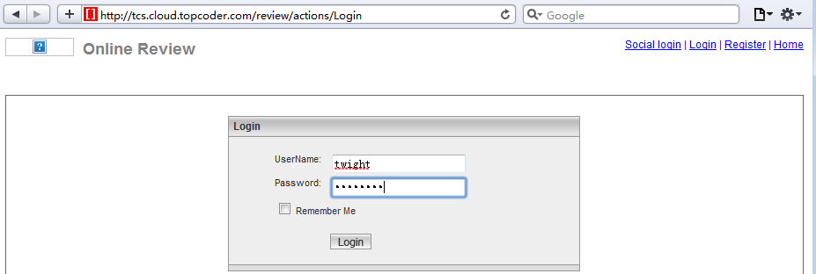

After logged-in, you can see the page as below.

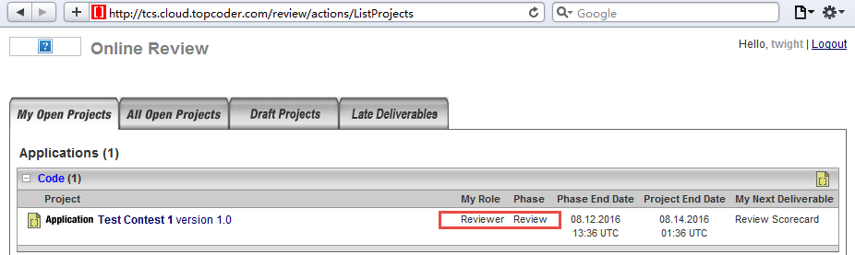

Open the contest page, and complete the review. It’s like this after the review is completed:

